LINCOLN COUNTY LIQUOR LICENSE
APPLICANT INSTRUCTIONS

The following is a list of the required steps for an applicant for liquor license.

1. Fill out the enclosed forms.
2. Obtain three (3) letters of recommendation.
3. Attach the applicable liquor license fee of $200.00
4. Provide a copy of the health certificate from the State of Nevada with the license applicant’s name included on the certificate. A letter from the State Department of Taxation showing proof of an account with that entity is also required.
5. Upon successful completion of the background check, this office will make arrangements for you to meet with the Lincoln County Liquor Board for approval of your license. You will be notified of the date and time of the meeting.

If you have questions, please call our office at (775) 962-8080 and ask for Heather.

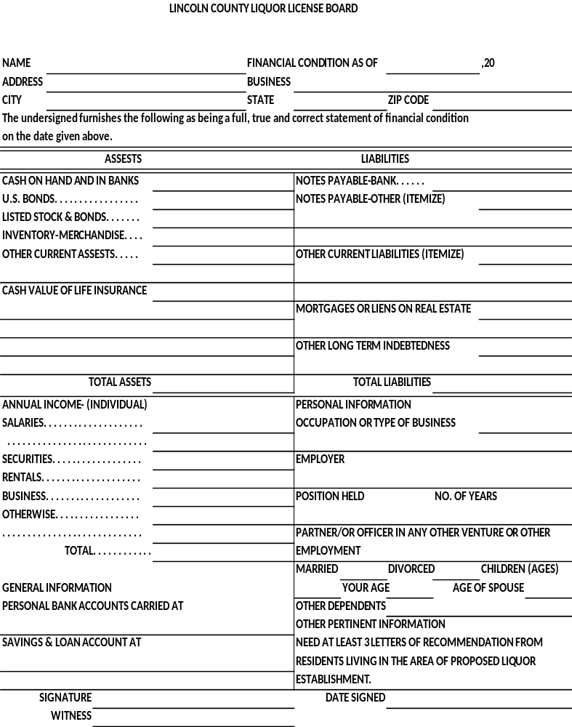
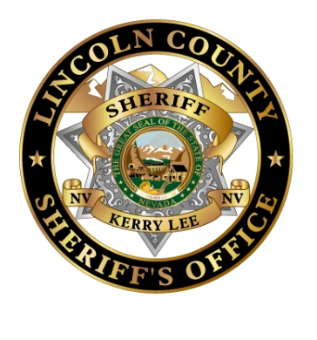

AUTHORITY FOR RELEASE OF INFORMATION
First Name Middle Name Last Name
__________________________________________________________________________________________________
Social Security # Date of Birth (MM/DD/YY) Place of birth (City, State, Country)
__________________________________________________________________________________________________

I, __________________________ do hereby authorize a review of and full disclosure of all records or any part thereof, concerning myself, by and to ANY duly authorized agent of the Lincoln County Sheriff’s Office whether the said records are of public, private or confidential nature.
The intent of this authorization is to give my consent for full and complete disclosure of the records of educational institutions, financial or credit institutions, include records of deposits, withdrawals and balances of checking and savings accounts, and loans, and also the records of commercial or retail credit agencies (including credit reports and/or ratings, public utility companies, employment and pre-employment records, including background reports, efficiency ratings, complaints or grievances filed by or against me, and salary, records, real and personal property tax statements and records and other financial statements and records wherever filed; records of complaint, arrest, trial and/or convictions for alleged or actual violations of law, including criminal, civil and/or traffic records, the results of any polygraph examinations; records of complaint of a civil nature made by or against me.
I reiterate, and emphasize that the intent of this authorization is to provide full and free access to the background and history of my personal life, for the specific purpose of pursuing a background investigation, which may provide pertinent data for the Lincoln County Sheriff’s Office to consider in determining my suitability for a liquor license. It is my specific intent to provide access to persona information, however personal or confidential it may appear to be, and the sources of information specifically identified herein.
I understand that any information obtained by the personal history background investigation which is developed directly or indirectly in whole or part; upon this release authorization will be considered in determining my suitability for a liquor license with Lincoln County, and will not be returned to me.
I agree to indemnify and hold harmless the person to whom this request is presented and his agents and employees, from and against all claims, damages, losses and expenses, including reasonable attorney’s fees, arising out of or by reason of complying with this request. I further understand that in the event my application is disapproved, the sources of confidential information cannot be revealed to me.
I agree that a photocopy of this release form will be valid as an original hereof, even though the said photocopy does not contain an original writing of my signature.
MUST BE SIGNED IN THE PRESENCE OF A NOTARY BEFORE SUBMISSION
Signature_______________________________________________________________________
Subscribed and sworn before me this ________day of_________________, _________________
County________________________ State__________________________
Notary Signature______________________________ My commission expires_______________
Stamp

Type Of Liquor License Applied For:

Wholesale Liquor Sales:
Retail Liquor Sales:
Packaged Liquor Sales:
Beer & Wine Liquor Sales:

Total Fees Remitted With This Application: $ 200.00

All applications must include a financial statement, applicable liquor license fee, and at least three letters of recommendation from residents living in the area of the proposed liquor establishment.
We, the undersigned petitioners, are all of the persons who shall conduct or have an interest in business for which a liquor license is requested.

Applicant(s): ____________________________________________________
____________________________________________________
____________________________________________________
____________________________________________________
____________________________________________________

Dated this ______ day of __________________________, 20___.

Applicant(s) Name: ______________________________________________________________
Doing Business As:________________________________________________________________

Presented to the Lincoln County Liquor Board on the __________ day of _______________,
20 ___.

Approved Denied

Lincoln County Sheriff

Lincoln County Liquor Board

